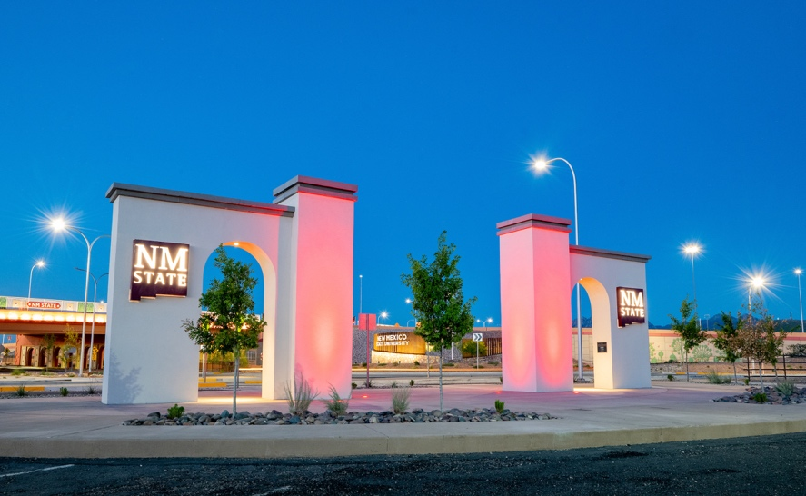z

Subheading

Presenter Name

**HEADING**

Subheading