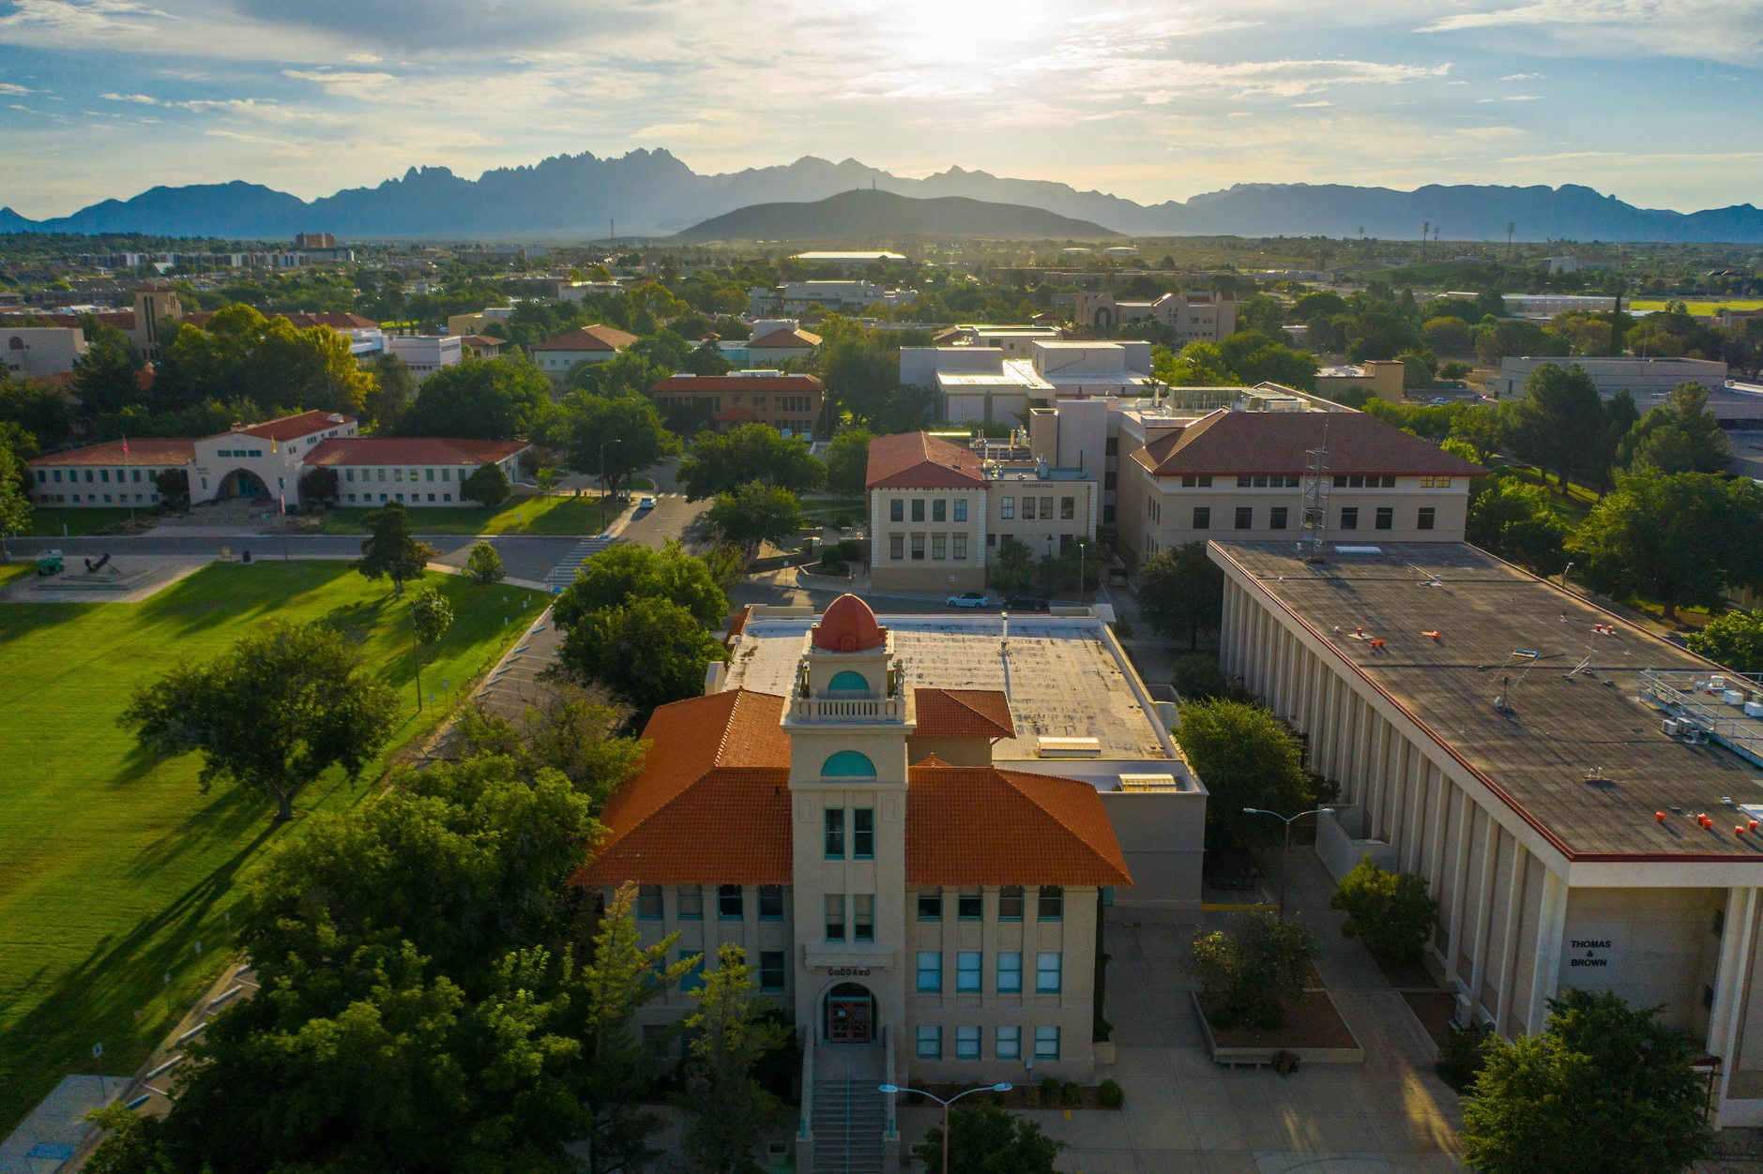

Presenter Name

Subheading

**HEADING**